4. Musical Ear: What **three songs** would be on the soundtrack of your character’s life? Include artist name, song titles, and **specific lyrics**. THEN explain how they fit your character’s soundtrack.

3. Neck: What (not who) stresses your character out and is a pain in his/her neck? Any ideas on how they could solve this problem?

2. Ear: What **compliments** do you think that your character would like to hear from others? Why?

1. Brain: Your character must write about their favorite memory from the time period of the book. What is it **and why**?

15. Mouth: What is the **most important advice** your character could give to another within the novel? Why?

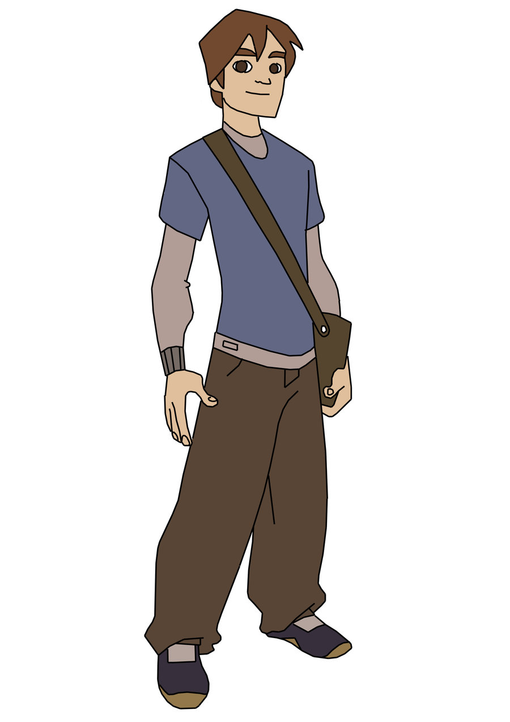

5. Smile: Looking at your character’s personality, what is one thing that **would keep them smiling**? Why?

Character: An individual in a narrative represented by thoughts, action, and physical description.

Assignment: Using parts of the body or clothing as Metaphors, bring to life the characters of *The Necklace.*

Use the back to draw either the wife or husband and pick at least FIVE examples to annotate.

13. Finger: Your character has **a magic touch**. What is it? What do they value and what is important to them? Why?

6. Watch: What will your character be doing in 10 years? Write about what you think they will be doing based on their decisions and personality so far in the book and explain **why you think that**.

11. Feet: If your character were to walk into your school and **give a presentation** to all the students, what would the presentation be about? What would **you want to hear**? Why?

10. Achilles Heal: What is your character’s **biggest weakness**? Why?

9. Heart: Your character is bored. They need a change of plans. Looking at your **character’s strengths and interests** what would be the perfect hobby for them to take up and why?

12. Legs: Which **obstacles** have your character had to face in order to be successful? Pick the **top three** and explain how they have made your character who they are.

8. Shoes: Pretend that the **name brand** of shoe is an **adjective** that most closely describes who you are and what you try to be. What would your character’s name brand of shoes be and why? Try and use a real name brand and explain how that brand fits the character’s personality.

7. Hand: Your character is about to write a **children’s book**. What would the title be and what would be one of the major themes of this book? Why?

14. Stomach: Your character is asked to invite **three people from history** over for dinner. Which three will s/he invite and **why**?